1. **BIT ADDITION**

**EXP NO: 5**

**AIM:** To write an assembly language program to implement 16-bit addition using 8085 processor.

**ALGORITHM:**

1) Start the program by loading a register pair with address of 1st number.

2) Copy the data to another register pair.

3) Load the second number to the first register pair.

4) Add the two register pair contents.

5) Check for carry.

6) Store the value of sum and carry in memory locations.

7) Terminate the program.

**PROGRAM:**

LDA 3050

MOV B,A

LDA 3051

ADD B

STA 3052

LDA 3053

MOV B,A

LDA 3054

ADC B

STA 3055

HLT

**INPUT:**

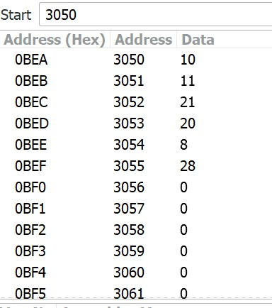

**OUTPUT:**

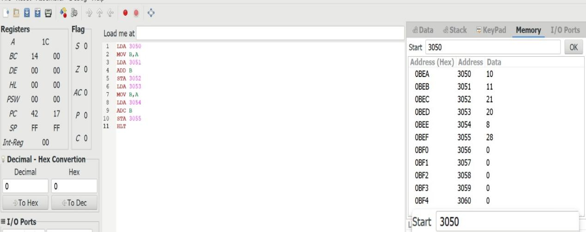

**RESULT:** Thus the program was executed successfully using 8085 processor simulator.